Task 1

R1

R2

Extra credit: simulate in spice

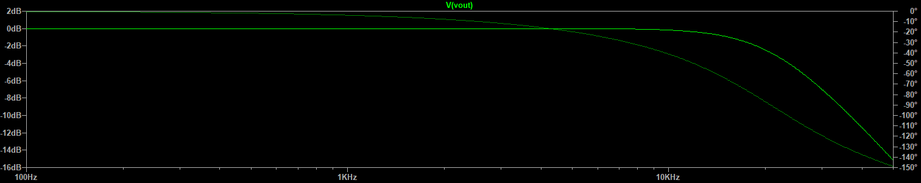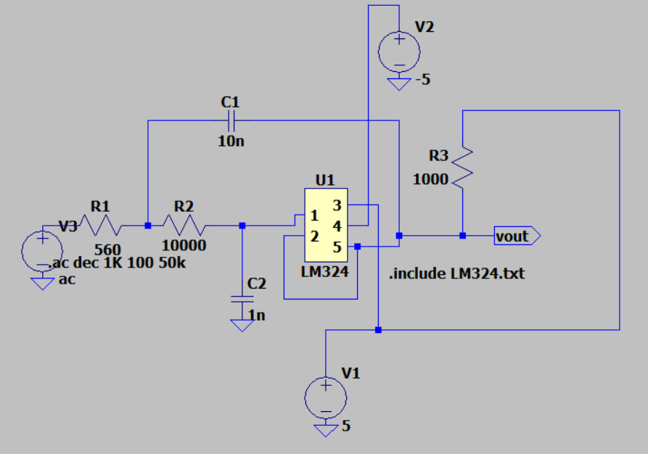

-3 dB at 21,300 Hz

Measure gain and phase response from 100hz to 50khz

FRA:

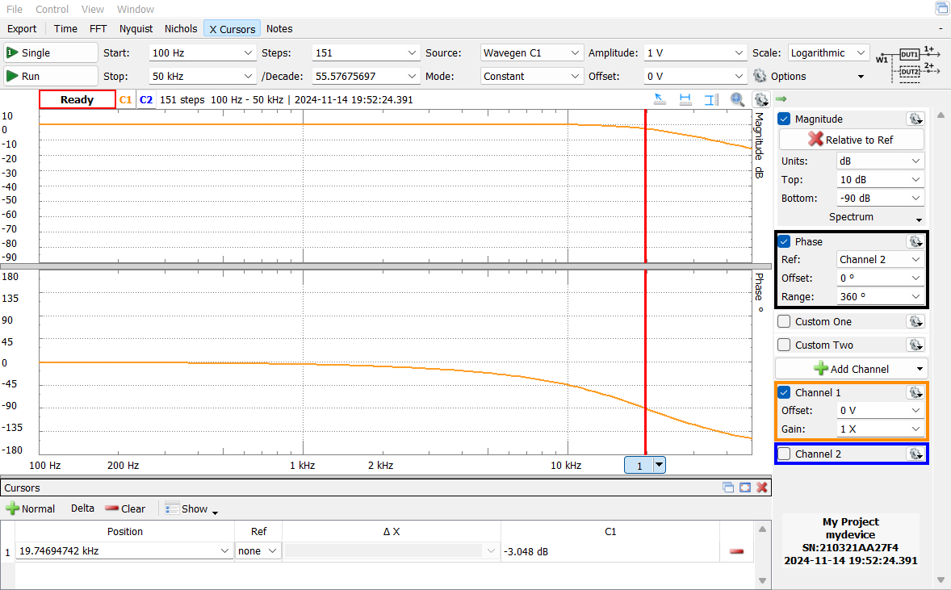

Oscilloscope screenshot showing vin and vout at cutoff freq

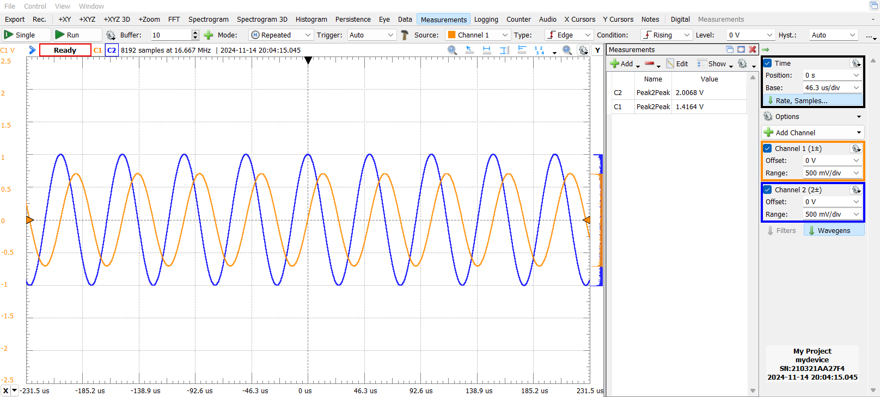

Calculate error between ideal and the cutoff frequency found

Task 2

Calculate cutoff freq

Measure freq response for .2hz<f<20hz , .1vpp input

Extra credit: replace –5v supply wit ground and apply .1vpp 2hz sin wave to vin

Capture oscilloscope

**Task 3**

Aim the transmitter LED at the receiver phototransistor and capture an oscilloscope printout showing 𝑣IN and 𝑣PT

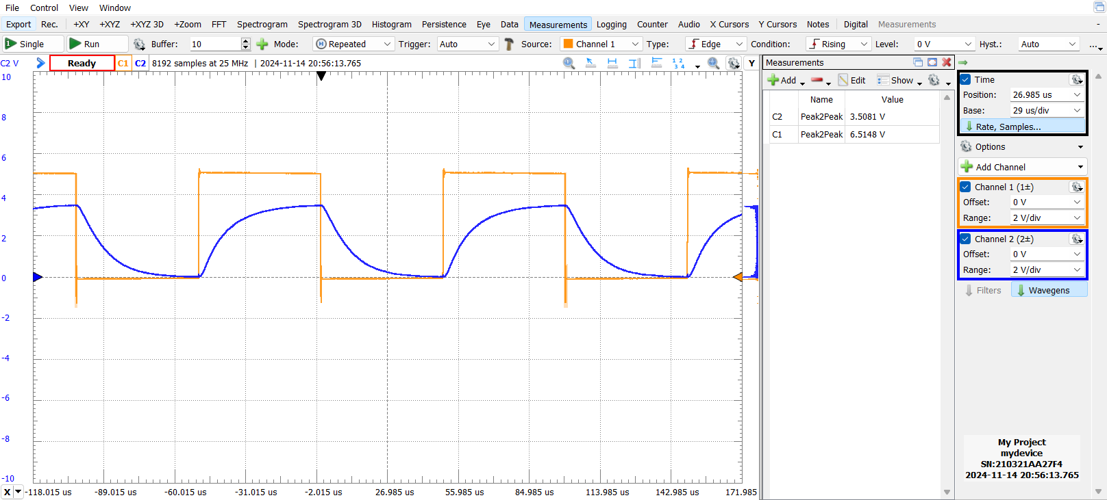

Measure the magnitude and phase response of the circuit using a 50 mVp−p sine  
wave as 𝑣PT and measure the center frequency, gain at the center frequency, bandwidth, and 𝑄 of the filter using the magnitude response of the circuit.

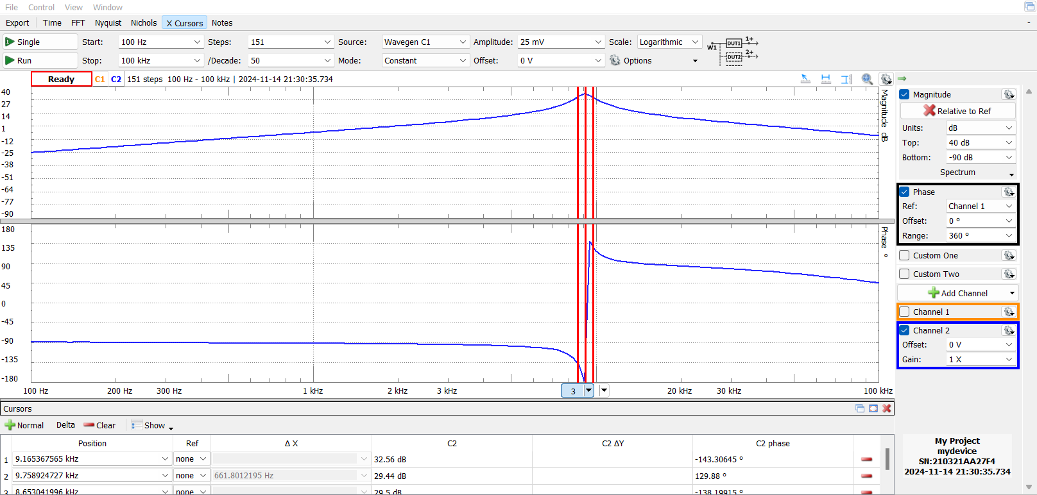

11. Capture an oscilloscope screenshot of 𝑣IN and 𝑣FILT

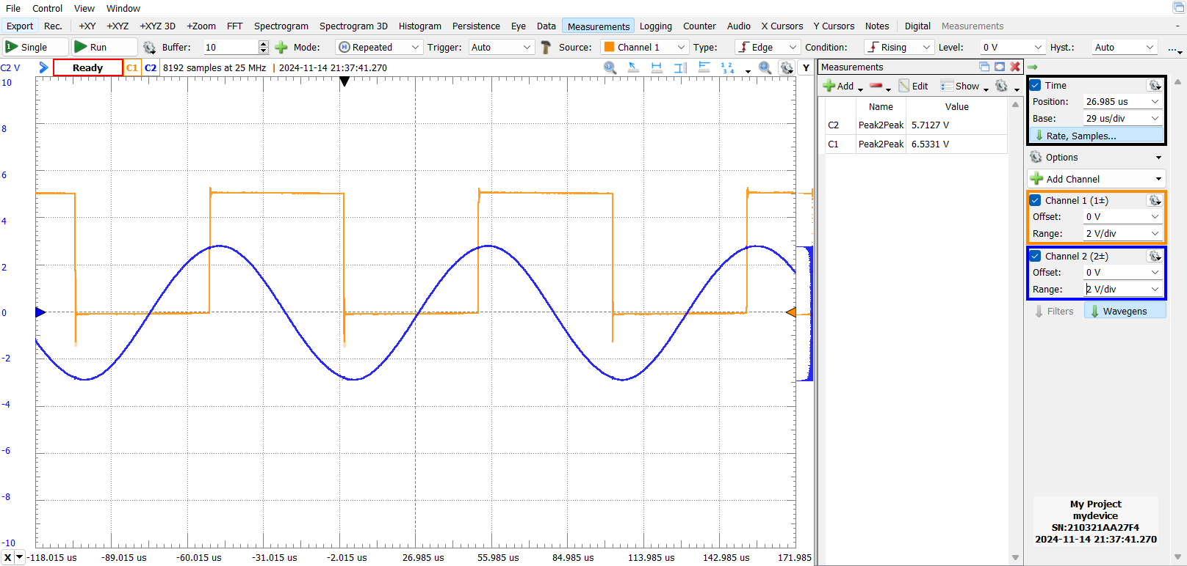

Record the peak to peak voltage of 𝑣FILT while sweeping the square wave frequency

of 𝑣IN from 1 kHz to 20 kHz. Record at least one data point per 500 Hz.